# 

***Connecting Networking and Agriculture***

Sukryul Lim, ChangHo Seo, Yunchang Chae, Sumin Lee

ChanHyeok Jun, and Aidan Mais

Kyungpook Univ, Sejong Univ, Jeju Univ, and Purdue Univ.

Table of Contents

[Introduction 3](bookmark://_Toc17037586#_Toc17037586)

[1.1 Overview & Background 3](bookmark://_Toc17037587#_Toc17037587)

[1.2 Project Objectives 3](bookmark://_Toc17037588#_Toc17037588)

[1.3 Project Challenges 3](bookmark://_Toc17037589#_Toc17037589)

[Research 4](bookmark://_Toc17037590#_Toc17037590)

[2.1 APRS 5](bookmark://_Toc17037591#_Toc17037591)

[2.2 SDR 5](bookmark://_Toc17037592#_Toc17037592)

[Design 5](bookmark://_Toc17037593#_Toc17037593)

[3.1 Hardware 5](bookmark://_Toc17037594#_Toc17037594)

[3.2 Software 6](bookmark://_Toc17037595#_Toc17037595)

[3.3 Test 7](bookmark://_Toc17037596#_Toc17037596)

[Development 10](bookmark://_Toc17037597#_Toc17037597)

[Test 20](bookmark://_Toc17037598#_Toc17037598)

[5.1 Availability Test 20](bookmark://_Toc17037599#_Toc17037599)

[5.2 Stability Test 27](bookmark://_Toc17037600#_Toc17037600)

[Evaluation 28](bookmark://_Toc17037601#_Toc17037601)

[6.1 Overall Evaluation 28](bookmark://_Toc17037602#_Toc17037602)

[Future work, Conclusion 28](bookmark://_Toc17037603#_Toc17037603)

[7.1 Future work 28](bookmark://_Toc17037604#_Toc17037604)

[7.2 Conclusion 29](bookmark://_Toc17037605#_Toc17037605)

[References 29](bookmark://_Toc17037606#_Toc17037606)

# Introduction

## 1.1 Overview & Background

The United States of America has vast areas of plain fields making them a huge food supplier for the world. Farmers in Indiana must deal with a huge amount of workload every day, taking care of their crops to increase yields. The workload doesn’t allow the farmers much time for checking the soil or climate conditions for their vast fields, which is quite crucial information to their mass production. Also, the climate of Indiana is very changeable across the field in scales of just a couple acres. This situation calls for a smart solution that can inform the farmers of crucial information concerning their fields. This project suggests agricultural IoT system as a solution.

## 1.2 Project Objectives

The objective of this project is to build a system that helps the farmers make better informed decisions when it comes to managing their crops and farms. The system will be designed with RF signal network to transmit real-time measured data (temperature, humidity, etc.) from different parts of the farmer’s fields. By informing them real-time agricultural conditions of their fields, the system can help the farmers to manage their whole farms, thus increase their gross production as well as the quality of the products.

## 1.3 Project Challenges

Previous research has designed the similar network system with LoRa Network. Their technical limit was communications between collection points and the sensors throughout the field. The penetration rate of LoRa signal was not good enough to send their data through the thick vegetation found in fields. project’s challenge is to build the network using lower frequency, allowing the network to propagate through any kind of crops. To achieve this goal, the network will be based on APRS (Automatic Packet Receiving System) Protocol which runs in 144.390 MHz in US.   
  
 The circuit is designed for receiving a sensed data from humidity & temperature sensor and GPS sensor, and transmit the data within APRS as shown in the diagram below.

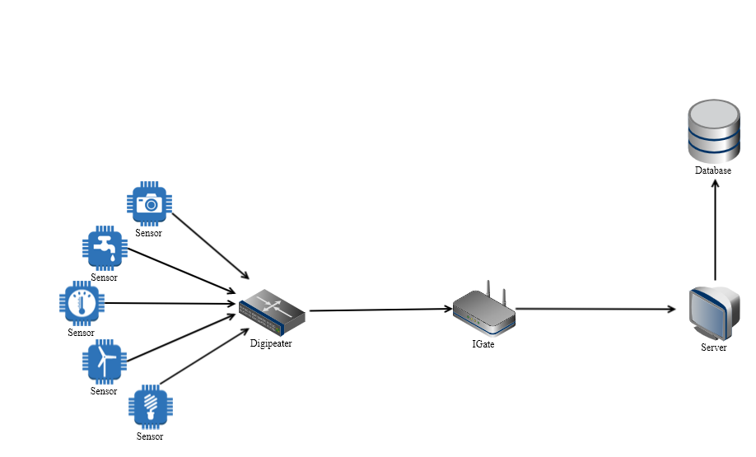

The sensed data will be transmitted from the sensor node which is built based on Arduino board. The digipeater will receive the data and will send it to IGate. Then the IGate will send the data, which it received through APRS network, to the server via the internet for later use. This data is useful for Decision making, data analysis for future crops, as well as counter actions that can be taken in the moment to increase crop growth.

This project will focus on connection availability and test APRS RF signal(144.390MHz) from the sensor node (Transmitter) to digipeater or IGate (Receiver).

# Research

The need for a network system that is appropriate for IoT in agricultural environment has called for a study with similar subject earlier. The previous projects had made the network with LoRa protocol. This network used 2.4GHz frequency which couldn’t propagate through the water in the crops on the field. Thus, another way for propagating network was needed. It had to be long range, stable, simple and powerful. APRS system seemed appropriate for the purpose. The sections below document the researches for the related technologies.

## 2.1 APRS

The Automatic Packet Reporting System is a network system based on amateur radio system for real time digital information communication that covers area and multiuser. The system transmits data on single shared frequency (144.390 MHz for U.S.A.). The data have been coded using X.25 Protocols. Data can be simple information such as GPS locations, temperature in forms of strings. This formatted data is sent in packets helping to prevent data loss and provide concise communication. The system was initially designed for short distance real-time crisis operations. Among all the differences that APRS has with other radio networks, the biggest issue is the real time updates of small amount of data. This feature makes the APRS network adequate for agricultural IoT.

## 2.2 SDR

Software Defined Radio is a compact hardware platform that can cover various different Wireless Network by reconfigurable software in the hardware. This means you can reconstruct the structures of the RF modules which has been consisted of hardware, now with software. It can define bandwidths, modes, functions of the radios by software which expands the functionality of the platform and lowers the hardware dependency.

# Design

This project is focused on APRS connection between the sensor node and IGate node. This section will describe each part of network in this project with hardware, software and network part. We decided to use GitHub to share the codes and documents, and we used Arduino to make our own sensor and IGate nodes.

## 3.1 Hardware

As far as hardware goes, we will use a temperature, humidity sensor and GPS sensor to relay some basic but crucial information for testing, we will also use 144.390MHz frequency antennas to send our data.

Parts and devices for this project is in below

|  |  |
| --- | --- |
| Transmitter | HX1-144.390-3 APRS Transmitter chip,  Argent Data Systems Radio Shield 2.1 |
| GPS sensor | Adafruit Ultimate GPS Breakout V3, uFL antenna |
| Temperature & Humidity sensor | Arduino Temperature and Humidity Sensor DHT11 |
| Antenna | Tram 1081-FSMA (144MHz/430MHz Dual Band Antenna) |
| Receiver | Ettus USRP B200 SDR Board,  BF-F8HP (Handheld Radio) |

## 3.2 Software

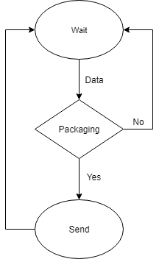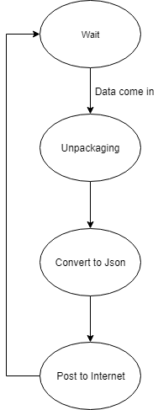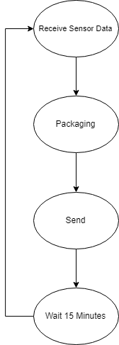Flowchart for digipeater Flowchart for IGate node Flowchart for sensor node

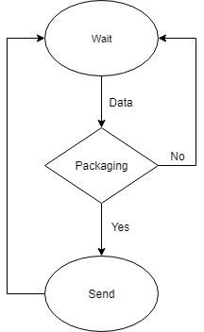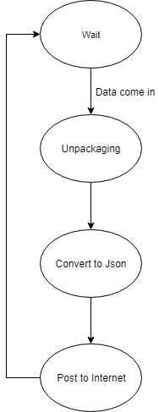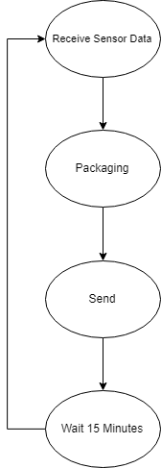

Digipeater, IGate and sensor nodes are based on Arduino, so all codes are based on C++.

## 3.3 Test

1st test field location

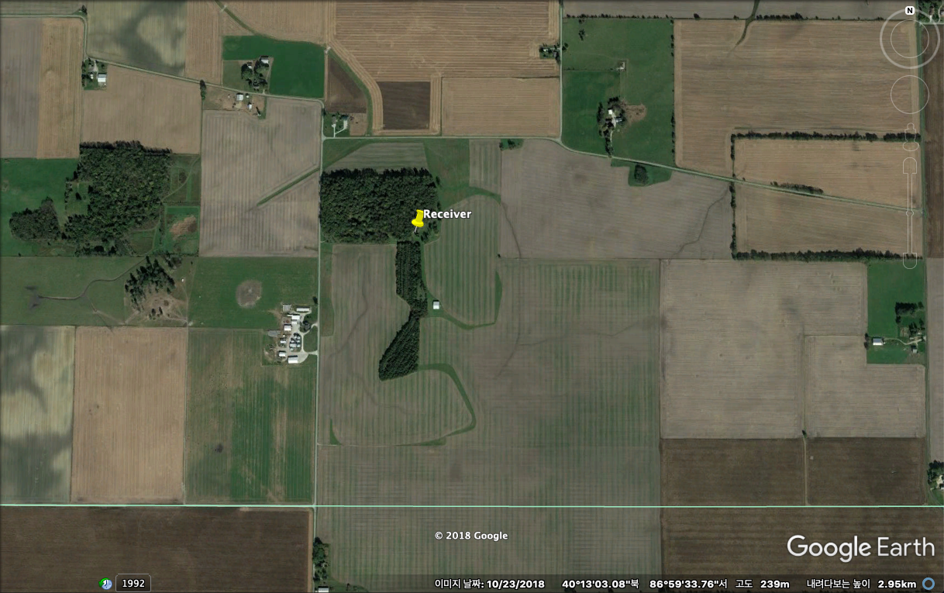

Dr. Anthony H Smith’s private farm

Romney, IN 47981

2nd test field location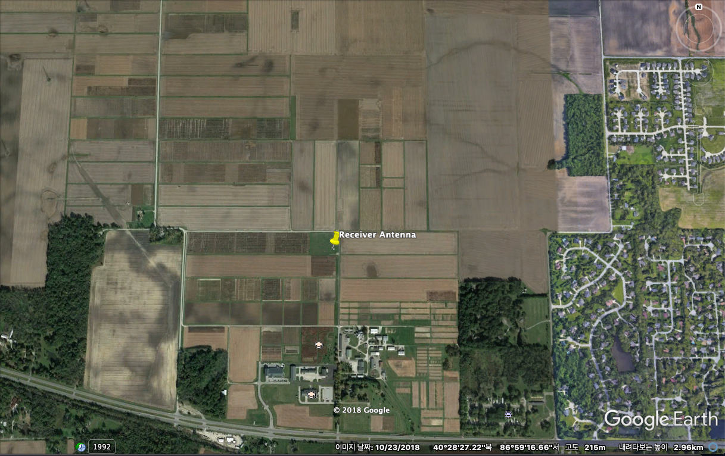

Purdue ICSIC

4750 US-52, West Lafayette, IN 47906

# Development

4.1 Hardware

A device which transmit measured data is built with a Radio shield2 for Arduino, a DHT11, a GPS, a HX1-144.390 transmitter chip and an antenna.

Following figure [1] is a circuit diagram of DHT11 sensor to measure temperature and humidity.

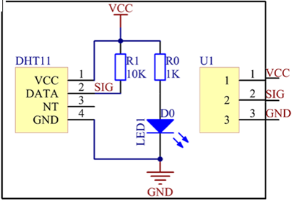

Three pins from U1 port of DHT11 are connected to the Arduino.

|  |  |  |
| --- | --- | --- |
| Pin | Name | Function |
| 1 | Vcc | Power supply 3.5V to 5.5V |
| 2 | Data | Outputs both Temperature and Humidity through serial Data |
| 3 | Ground | Connected to the ground of the circuit |

The sensor uses 5V as a power source from the Arduino. The SIG pin is connected to Analog 01 pin to send measured data to Arduino.

Following figure [2] is a circuit diagram of GPS sensor to measure date, longitude, latitude and satellite data. 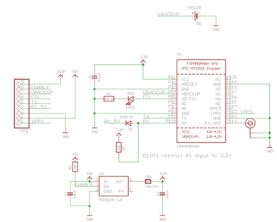

Nine pins from JP1 part of the GPS sensor are connected to the Arduino.

|  |  |  |
| --- | --- | --- |
| Pin | Name | Function |
| 1 | 3.3v | Power supply 3.3v provide at least 100mA output |
| 2 | EN | Turn on/off the GPS module. |
| 3 | VBAT | Input battery under the 3.3V pin: GPS real time clock battery backup |
| 4 | FIX | Output pin |
| 5 | TX | Transmit data from the GPS module to Arduino in 3.3V logic level. |
| 6 | RX | Send data to the GPS in 3.3V or 5V logic |
| 7 | GND | Connected to the ground of the circuit |
| 8 | VIN | power supply 3-5VDC |
| 9 | PPS | pulse per second: logic low (ground) and pulses high (3.3V) once a second |

The Tx pin number 5 of the GPS sensor is connected to pin 8 of Arduino to transmit data from the GPS module. The Rx pin number 6 of the GPS sensor is connected to pin 7 of Arduino to send data to the GPS some logics.

Following figure is a pin diagram of HX1 transmitter to send packets from radio shield.

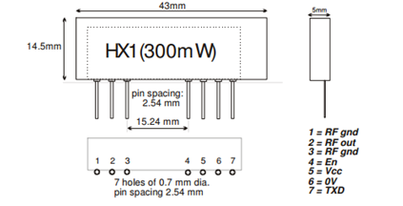

|  |  |  |
| --- | --- | --- |
| Pin | Name | Function |
| 1,3 | RF gnd | RF Ground |
| 2 | RF out | 50Ω RF output to the antenna |
| 4 | EN | Pull high to enable Transmitter |
| 5 | VCC | Power supply DC 5V |
| 6 | Gnd | Ground |
| 7 | TXD | DC coupled input for 5V |

Pin number 4 of transmitter chip is connected to pin 9 of Arduino to pull high the transmitter chip. The Tx pin transmits data from the Arduino pin 7 to transmitter chip. The antenna is connected to the pin 2 of the HX1 chip to amplitude the signal. The HX1 chip supports 300mW signal transmitting power by itself even when the antenna is not connected.

The Radio Shield 2 is an add-on for the Arduino development board that provides AX.25 packet radio sends and receive capability, a prototyping area, and an LCD interface.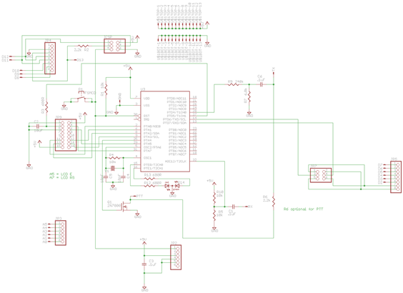

This figure is the whole circuit of the transmitter. It is not the same with the figure, the radio shield is placed on top of the Arduino. The Tx pin of HX1 transmitter is connected to Tx pin of Radio shield to get the packet which is formatted in AX.25 protocol.   
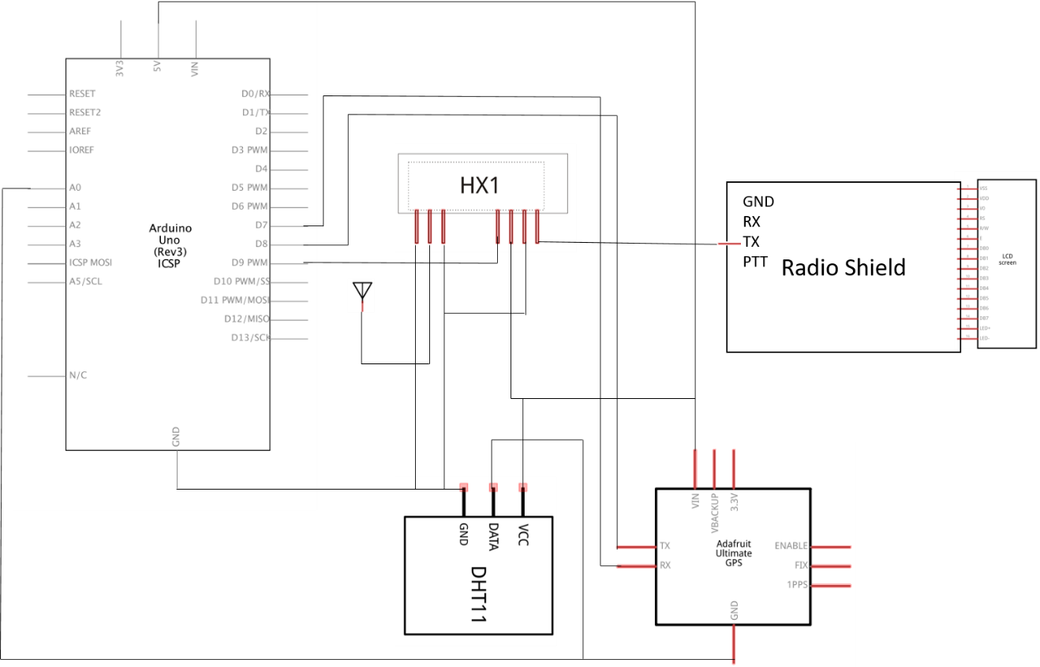

4.2 Software

There are two types of code in software part. One of them is the transmitter code that uploaded on Arduino. The other one is data receive code which is written in Python by GNU radio for SDR.

This figure below is a source code for Arduino. This code makes the transmitter device to collect temperature, humidity and GPS from each sensor and it transmits those data through 144.390Mhz frequency radio network.

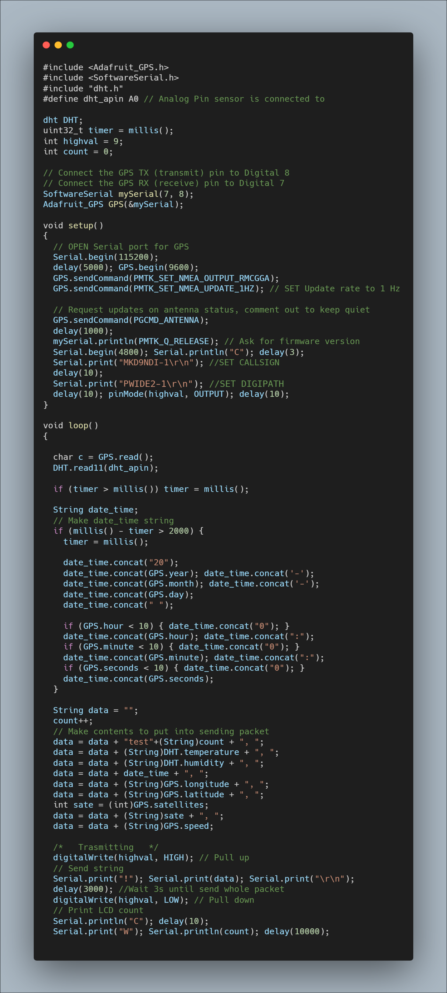

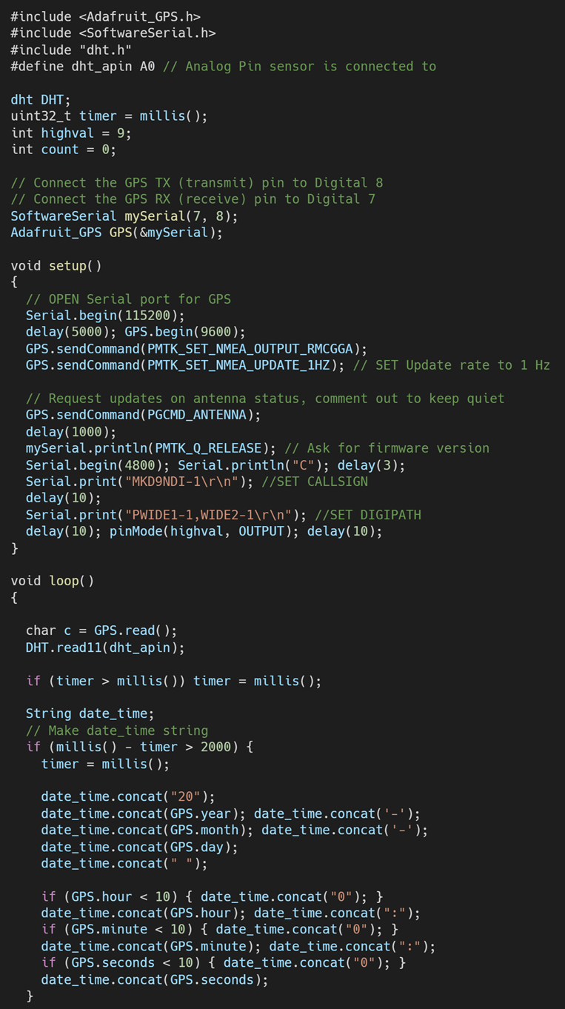

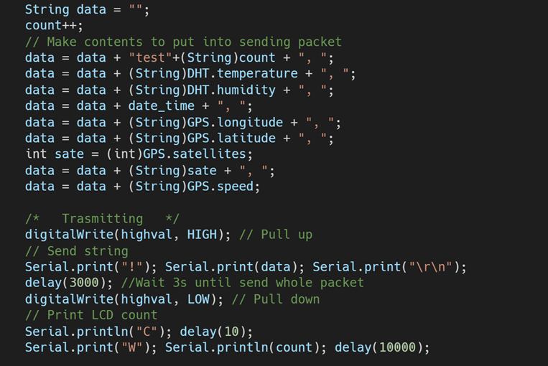

Radio shield interprets some reserved commands. The commands are communicated as a String with wildcard character through 4800 baud Serial port.

-LCD Command

|  |  |
| --- | --- |
| Command | LCD Function |
| W<text> | Write to LCD |
| G<line.column> | Go to LCD line (0 or 1) and column |
| C | LCD clear |
| H | LCD home |
| B<n> | LCD contrast, 0-1023 |

-Radio Command

|  |  |
| --- | --- |
| Command | Function |
| !<text> | Send plain text packet |
| @<text> | Send Morse code text |
| M<callsign> | Set my callsign (returns 1 for success) |
| S | Status. Returns 1. |
| V | Reports version. Added in firmware version 1.1. |
| L<0-255> | Set TX audio level (returns 1 for success) |
| D<0-255> | Set TX delay in 1/120 sec intervals (returns 1 for success) |
| P<path> | Set AX.25 path (e.g., WIDE1-1,WIDE2-1) |

This part of code is setting callsign and Digipath. The callsign is fixed with MKD9NDI which is permitted to use for Dr. Grant who owned the radio station in Purdue farm. The Digipath is decided to WIDE2-1 because it should be used by fixed stations and it will produce only one digipeater hop. In most cases, fixed stations already have the advantage of a better antenna and elevation than a mobile and it should be able to reach a true wide area digipeater without the aid of another home station. By the above table of radio commends, the first letters “M” and “P” are used to set the callsign and the Digipath as the wildcard characters. The “\r\n” is required to represent the end of command.

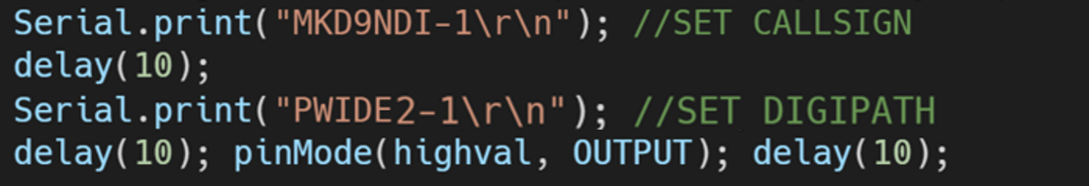

To enable the transmitter, the HX1 transmitter needs to be pull up. By the above table of radio commends, the first letters “!” needs to be used to send plain string. It is sent CR/LF (Carriage Return/Line Feed) to complete and transmit packet. After sending the packet, the Arduino has to wait more than 1 second until completing to send the whole packet. In this code, after waiting 3 seconds, transmitter is going to be disabled. This process will be repeated every 10 seconds.

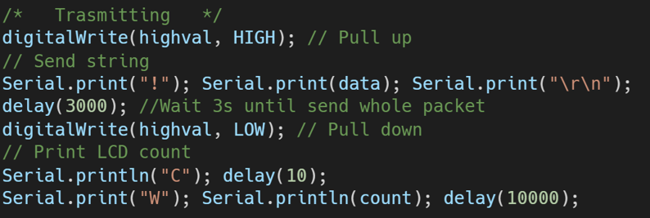

The following figure is a flow of gnu radio code block for SDR.

This is the link to install SDR which is using UHD driver and GNU radio on Linux.

<https://kb.ettus.com/Building_and_Installing_the_USRP_Open-Source_Toolchain_(UHD_and_GNU_Radio)_on_Linux>

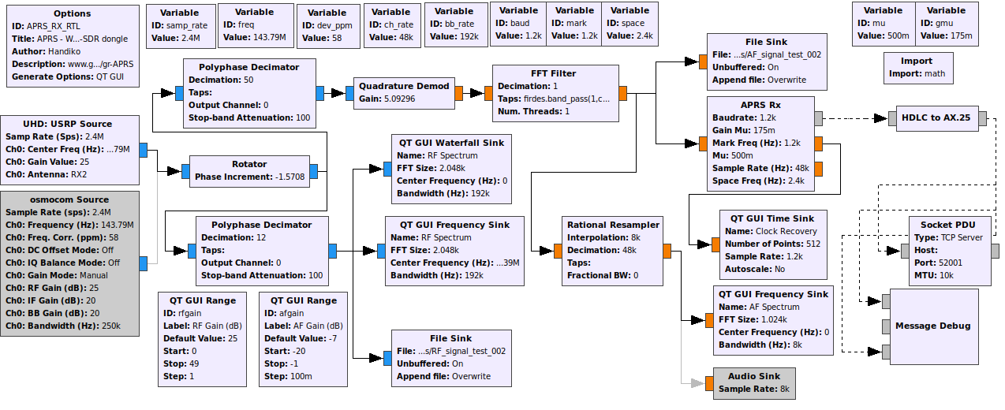

The result of execution shows four charts. The signal can be checked by the RF spectrum chart through the Relative gain value changes in real-time. When the transmitter sends the signal, the wave shows almost same shape in each cycle.

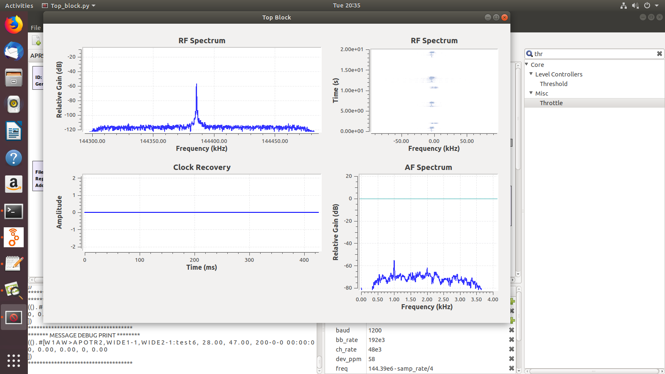

The contents of a received message can be seen through telnet with 52001 port.

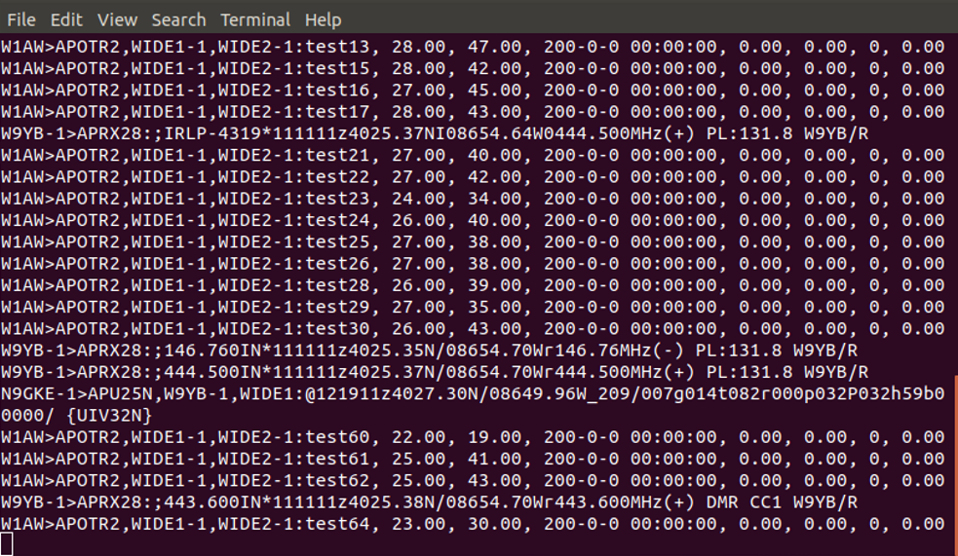

At the first, the content of packet was formatted with JSON. However, it needs to be smaller because the maximum Ax.25 protocol packet size is 107 bytes. Therefore, it changed to one string which enumerates only values.

# Test

From what we have built we designed series of tests to prove the usability of APRS for IoT in agricultural environment. There has been 2 tests at different sites, each testing the availability and stability of radio network.

## 5.1 Availability Test

Test Objective: See the availability of APRS network in various agricultural land scape (Forest, Corn, plane field).

Test Plan: Transmit the sensed data to Receiver (Handheld radio) as a tone to check the network availability. Transmitter is consisted with the Arduino boards HX-1 chip and sensors, Receiver will be BF-F8HP (Handheld Radio). If we hear the regular tones (as we have programmed in the Arduino boards) from the receiver, it means the network is working fine and receiving the data well.

Hardware measurements:

Antenna (Tram 1081-FSMA) gain on VHF: 2.14Dbi.

Measured IR dBm of the transmitter chip in sensor node: 15dBm

Test Results:

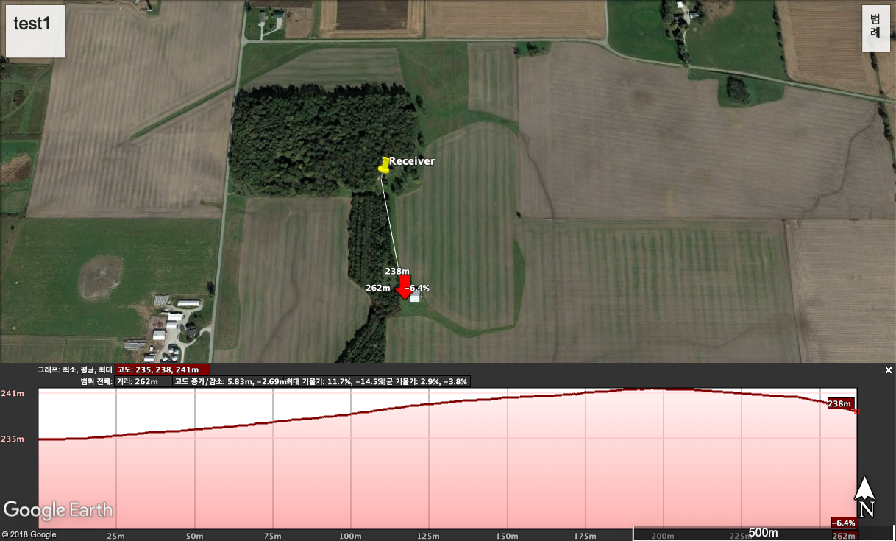

Test1:

Land type: Plane field

Distance: 262m

Elevation Difference: 3m

Tone availability: Available

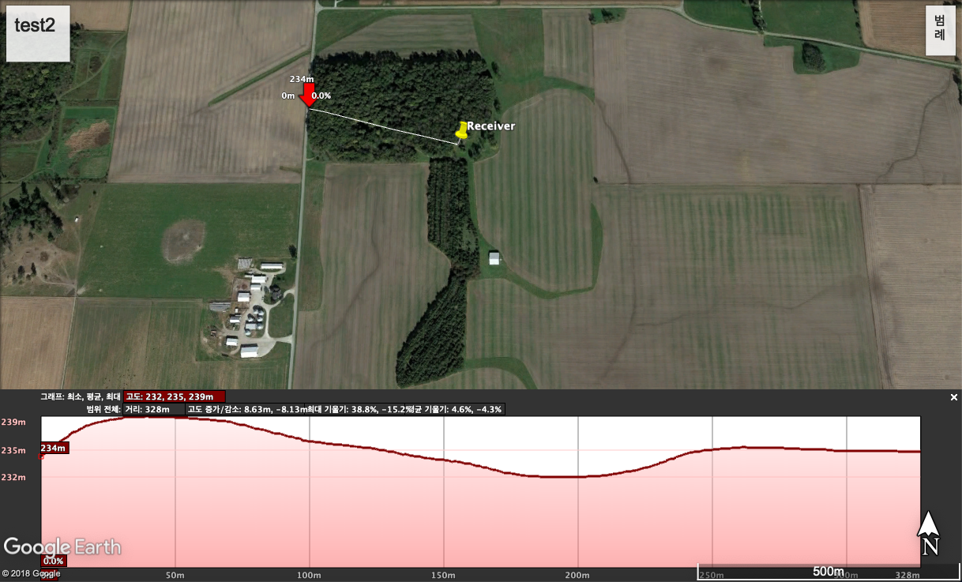

Test2:

Land type: Forest

Distance: 328m

Elevation Difference: 1m

Tone availability: Available

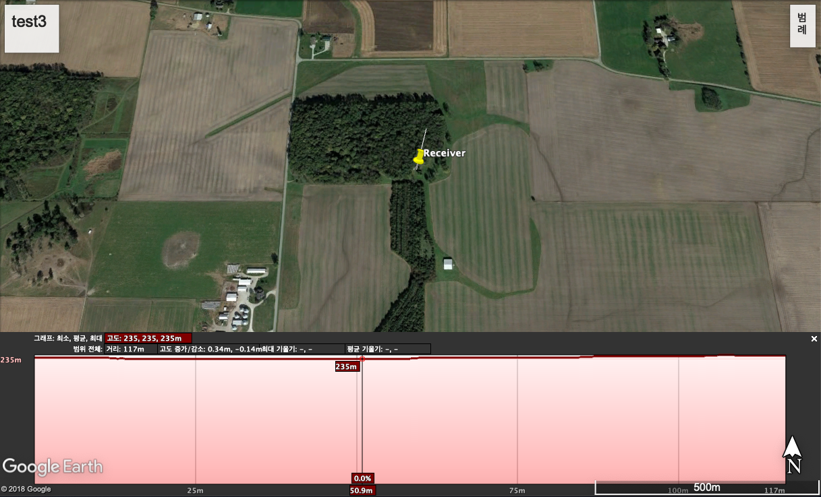

Test3:

Land type: Forest

Distance: 117m

Elevation Difference: 0.34m

Tone availability: Available

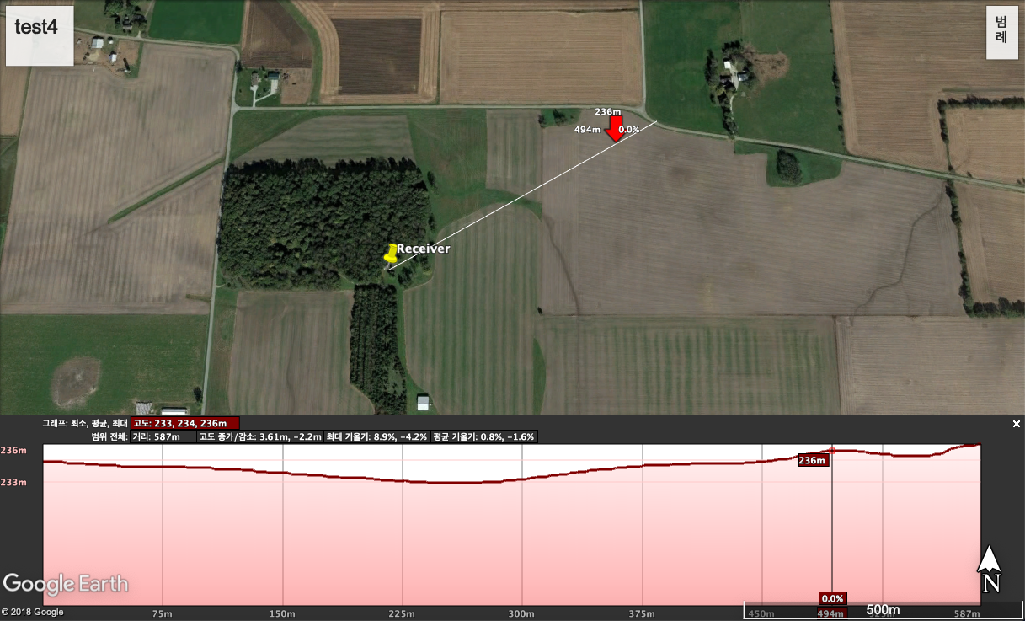

Test4:

Land type: Forest & Corns

Distance: 587m

Elevation Difference: 1m

Tone availability: Available

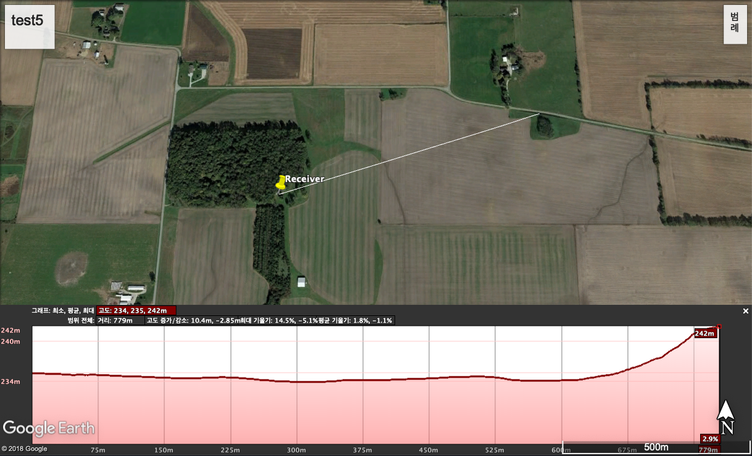

Test5:

Land type: Corns

Distance: 779m

Elevation Difference: 7m

Tone availability: Available

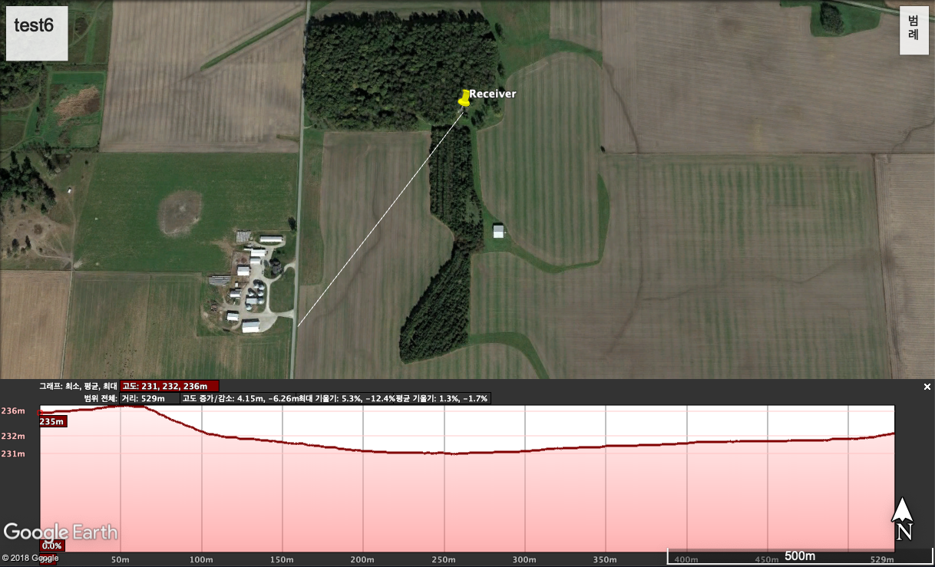

Test6:

Land type: Forest & Corns

Distance: 529m

Elevation Difference: 2m

Tone availability: Available

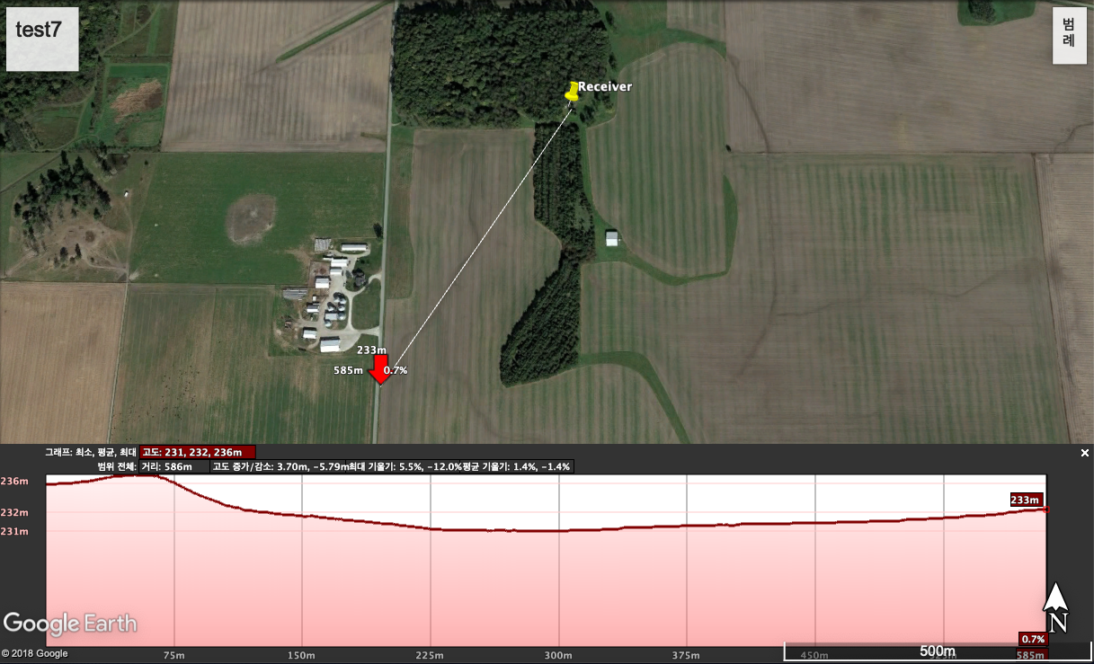

Test7:

Land type: Forest & Corns

Distance: 586m

Elevation Difference: 2m

Tone availability: Available

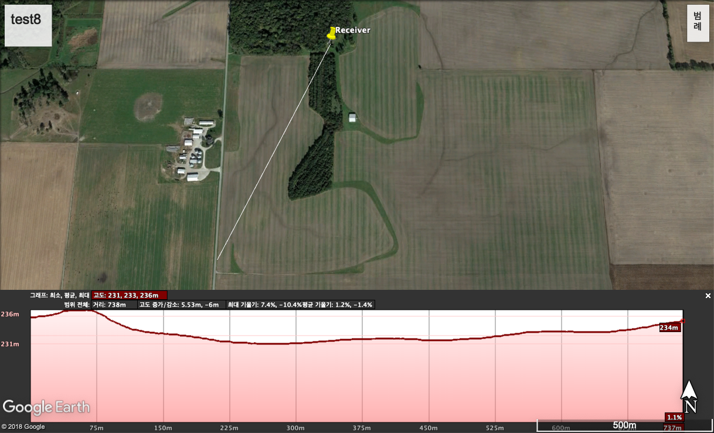

Test8:

Land type: Forest & Corns

Distance: 738m

Elevation Difference: 1m

Tone availability: Available

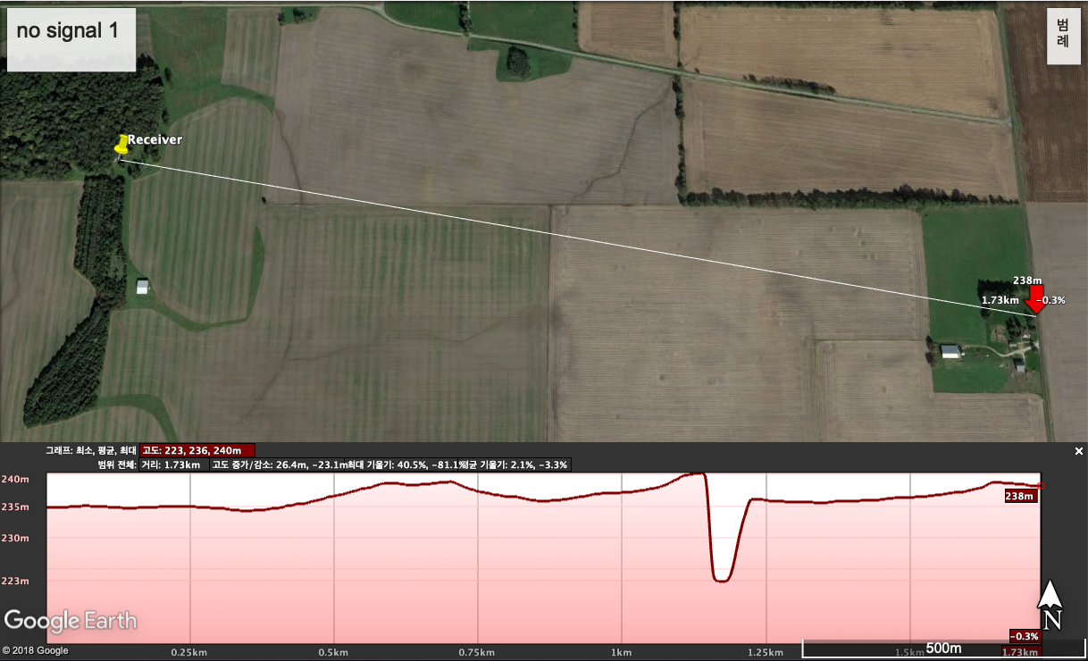

Test9:

Land type: Corns

Distance: 1730m

Elevation Difference: 3m

Tone availability: Not Available

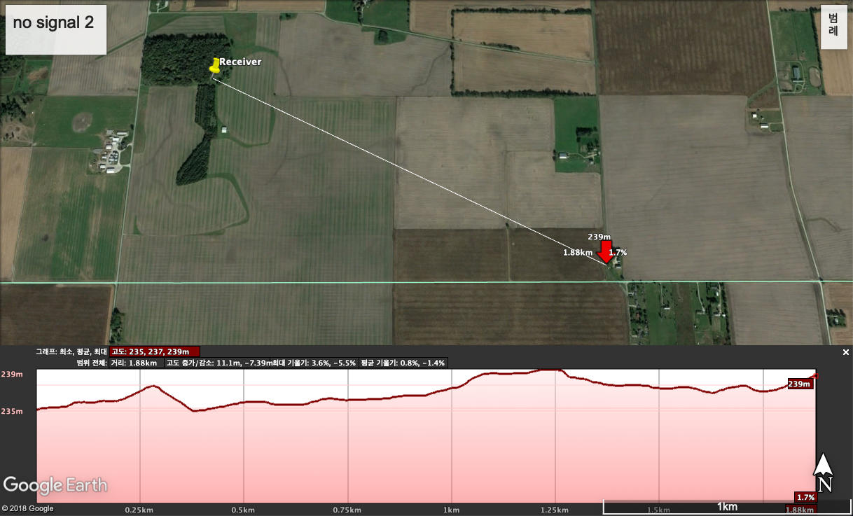

Test10:

Land type: Corns & plane field

Distance: 1880m

Elevation Difference: 4m

Tone availability: Not Available

Evaluation: Radio signal available under 750m range regardless of the land scale or obstacles between the transmitter and receiver. Needs to find main factor for the no connection when it comes to over 750m distance.

## 5.2 Stability Test

Test Objective: See the stability of APRS network system through various obstacles and distances.

Test plan: Sending counted test packets continuously, keep track of data reception. Compare the reception along distances and obstacles between transmitter and receiver.

Hardware measurements:

Transmitter Antenna (Tram 1081-FSMA) gain on VHF: 2.14dBi.

Receiver Antenna gain on VHF: 4.9dBi

Measured IR dBm of the transmitter chip in sensor node: 15dBm

Test01:

The following figure is the map of Purdue Farm. The section is divided as corn, bean and plain field. However, bean crops are not so high, bean and plain filed is distinguished equally.

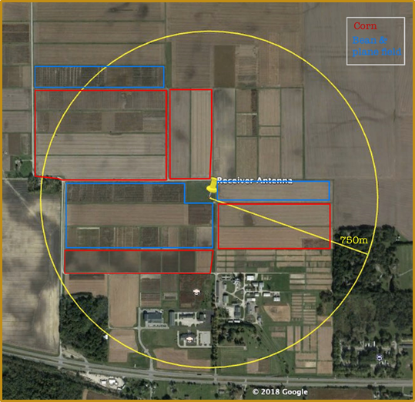

Evaluation: APRS packets were transmitted well with the limitation of 750m distance with any crops between the terminals. Packets were lost for the further distances up to 800m and there was no signal after 800m. Since there was no big difference in the RF signal gain value with in the 750m, no matter what the obstacles were, limitation of distance seems to be due to the low power to the transmitter.

# Evaluation

## 6.1 Overall Evaluation

Previous research has designed the similar network system with LoRa Network. Their technical limit was communications between collection points and the sensors throughout the field. The penetration rate of LoRa signal was not good enough to send their data through the thick vegetation found in fields. project’s challenge is to build the network using lower frequency, allowing the network to propagate through any kind of crops. To achieve this goal, the network will be based on APRS (Automatic Packet Receiving System) Protocol which runs in 144.390 MHz in US.   
  
 The circuit is designed for receiving a sensed data from humidity & temperature sensor and GPS sensor, and transmit the data within APRS as shown in the diagram below.

# Future work, Conclusion

## 7.1 Future work

It would be better to make input power high. If the power source were much more powerful, HX1 could be able to transmit signals farther away. Also, other two kinds of device need to be developed to make the whole process in APRS network up such as digipeater and IGate. In addition to this, defining values which need to be measured and actuating based on the meaningful data would be remarkable points to make every IoT service.

## 7.2 Conclusion

Communicating through a wireless network is difficult in an agricultural environment because of lots of crops. To compose agricultural IoT services, people have tried to find a radio wave having a suitable frequency and region for it. As a result of previous studies, the LoRa network was found to be unsuitable for agricultural environments. According to that, our team decided to use the lower frequency band 144.390 MHz. Using Arduino, which can perform with low power, sends several sensor values as a transmitter, and SDR was developed to see the data as a receiver. In two farms, tests were conducted under various conditions. Through some tests, we confirmed that the radio signals were sufficiently penetrating the crops and communicated enough well. In conclusion, APRS with 144.390Mhz band could be used in the agricultural environment successfully.

# References

https://www.tapr.org/aprs_information.html (APRS description)

To make a circuit diagram, we used a fritzing program.

[1] http://wiki.sunfounder.cc/index.php?title=Humiture_Sensor_Module

[2] https://learn.adafruit.com/adafruit-ultimate-gps/downloads

Vuran, M. C., Salam, A., Wong, R., & Irmak, S. (2018). Internet of underground things in precision agriculture: Architecture and technology aspects. Ad Hoc Networks, 81, 160-173.

Hartono, R., Hasbi, W., Choiriyah, I., & Yatim, R. (2019). Design of APRS Modem Using IC TCM3105 and ATMega2560 Microcontroller. arXiv preprint arXiv:1901.05292.

Hongyim, N., & Mithata, S. (2017, November). Designing and Implementation Exploration Vehicle Remote Controller Using APRS Protocol. In 2017 21st International Computer Science and Engineering Conference (ICSEC) (pp. 1-5). IEEE.